

**Green University of Bangladesh**

**Department of Computer Science and Engineering (CSE)**

**Faculty of Sciences and Engineering**

**Semester: (Spring,Year:2025),B.Sc.in CSE (Day)**

**LAB REPORT NO - 2**

**Course Title: Data Communication Lab**

**Course Code:CSE307 Section:223-D1**

**Lab Experiment Name : Implementing Bit Stuffing and De-stuffing**

**Student Details**

|  |  |  |
| --- | --- | --- |
| **Name** | | **ID** |
| **1.** | **MD.SHAJALAL** | **223002088** |

**Lab Date : 24-02-2025**

**Submission Date : 03-03-2025**

**Course Teacher’s Name : Md.Samin Hossian Utsho**

|  |
| --- |
| **Lab Report Status**  **Marks: ………………………………… Signature:.....................**  **Comments:.............................................. Date:..............................** |

1. **TITLE OF THE LAB REPOT EXPERIMENT**

Implementing Bit Stuffing and De-stuffing

**2.Objective:** To implement Bit Stuffing and De-stuffing using the C programming language.

**3. Theory:** Bit Stuffing is a data transmission technique used to prevent confusion with control flags in synchronous communication. When five consecutive '1' bits appear in the data, a '0' bit is inserted after them to differentiate from the flag sequence. De-stuffing is the reverse process, where these extra '0' bits are removed at the receiver’s end to retrieve the original data.

**4.Algorithm:**

**Bit Stuffing Algorithm:**

1. Traverse the input bit stream.
2. Count consecutive '1's.
3. If five consecutive '1's are encountered, insert a '0'.
4. Continue until the end of the input.

**Bit De-stuffing Algorithm:**

1. Traverse the stuffed bit stream.
2. Count consecutive '1's.
3. If five consecutive '1's are encountered followed by a '0', remove the '0'.
4. Continue until the end of the input.

**5. C Program:**

**Code:**

#include <stdio.h>

#include <string.h>

void bitStuffing(char *input, char *stuffed) {

    int i, j = 0, count = 0;

    for (i = 0; input[i] != '\0'; i++) {

        stuffed[j++] = input[i];

        if (input[i] == '1') {

            count++;

            if (count == 5) {

                stuffed[j++] = '0';

                count = 0;

            }

        } else {

            count = 0;

        }

    }

    stuffed[j] = '\0';

}

void bitDeStuffing(char *stuffed, char *original) {

    int i, j = 0, count = 0;

    for (i = 0; stuffed[i] != '\0'; i++) {

        original[j++] = stuffed[i];

        if (stuffed[i] == '1') {

            count++;

            if (count == 5 && stuffed[i + 1] == '0') {

                i++;

                count = 0;

            }

        } else {

            count = 0;

        }

    }

    original[j] = '\0';

}

int main() {

    char input[100], stuffed[150], original[100];

    printf("Enter the bit stream: ");

    scanf("%s", input);

    bitStuffing(input, stuffed);

    printf("Stuffed bit stream: %s\n", stuffed);

    bitDeStuffing(stuffed, original);

    printf("De-stuffed bit stream: %s\n", original);

    return 0;

}

**6.Output:**

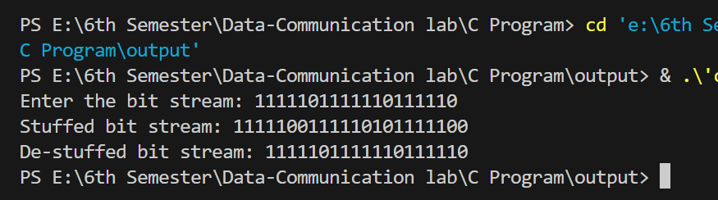

**7.Conclusion:** The Bit Stuffing and De-stuffing techniques were successfully implemented in C. The program correctly inserts and removes extra '0' bits while ensuring proper data transmission. The results verify the correctness of the implementation.